1. Load

LOAD operator is used to load data from the file system.

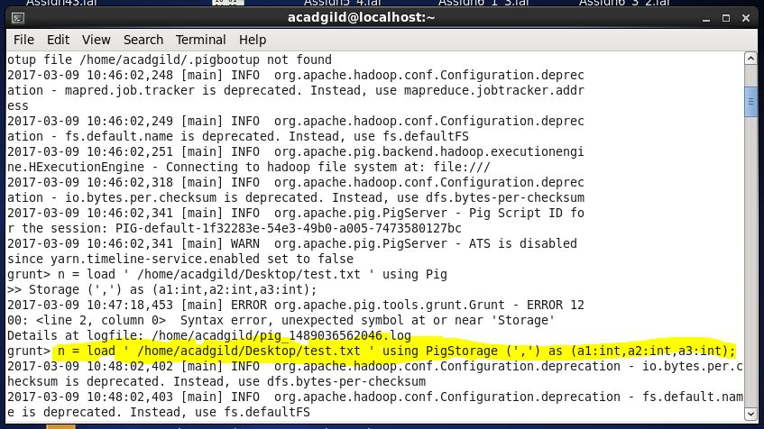

1. Limit

Used to limit the number of outputs to the desired number.

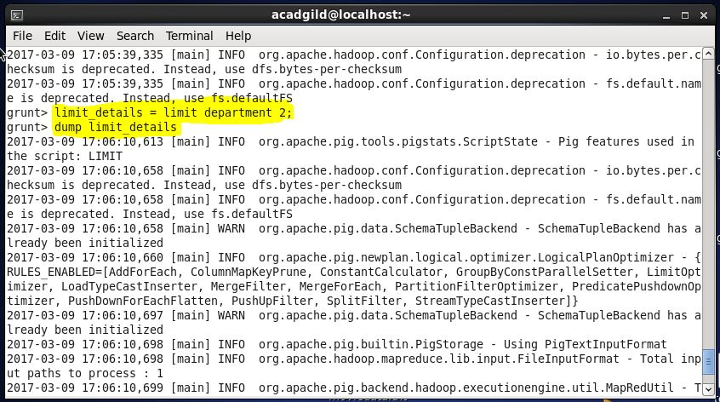

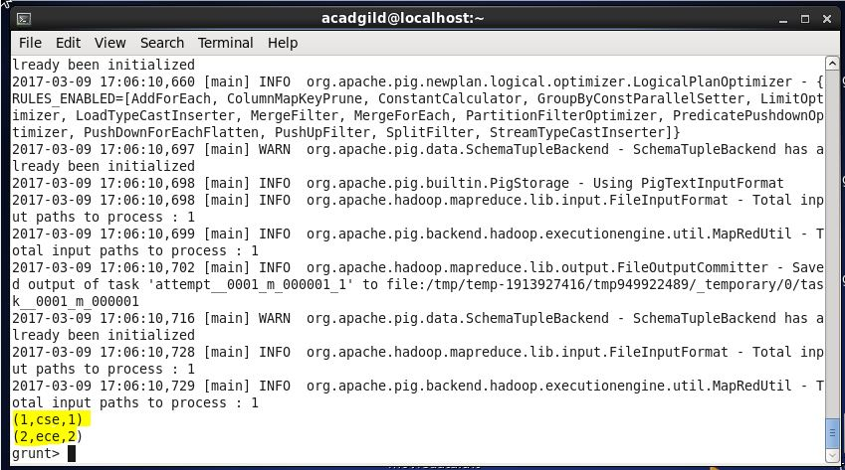

1. Store

After the data is loaded in Apache Pig. It can be stored in the file system using the store operator.

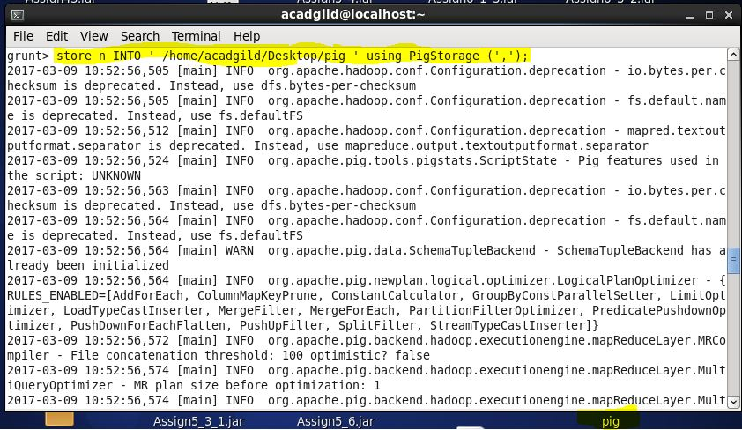

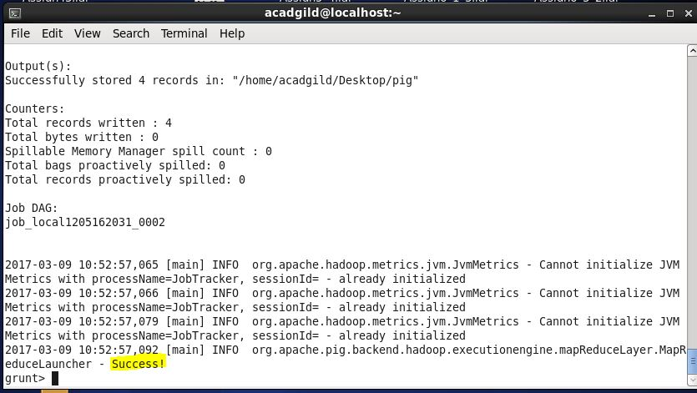

1. Dump

The Dump operator is used to run the Pig Latin statements and display the results on the screen.

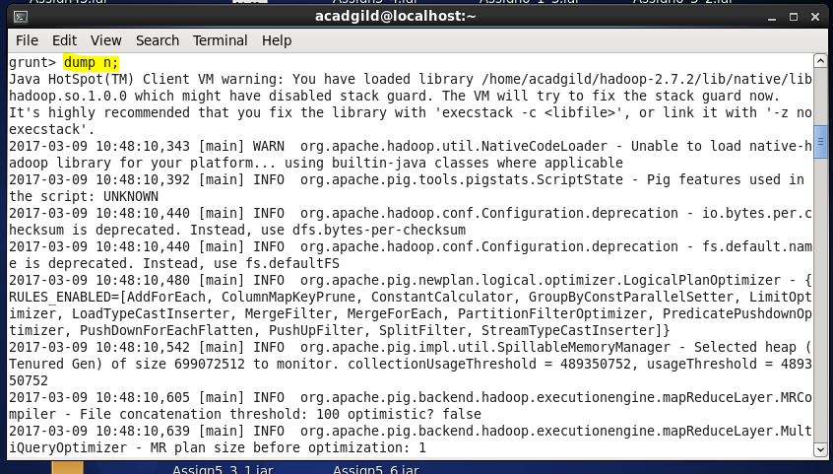

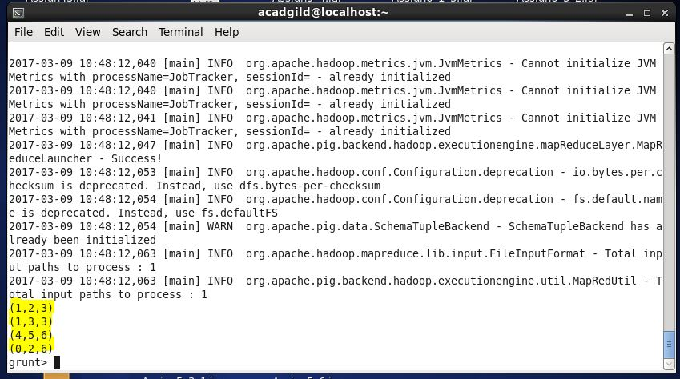

1. Foreach

The FOREACH operator is used to generate specified data transformations based on the column data.

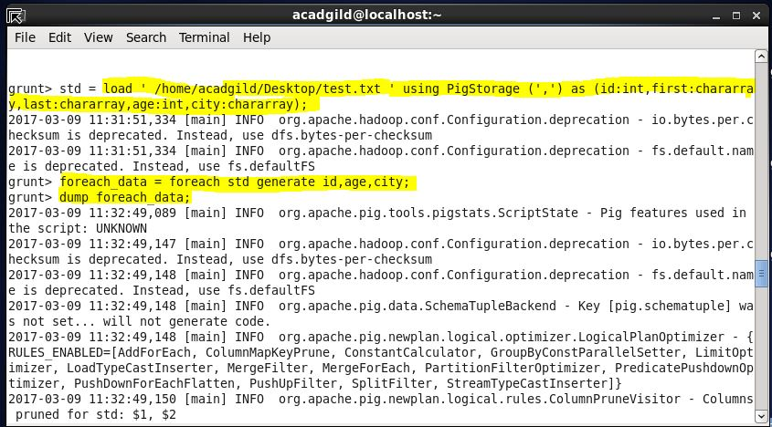

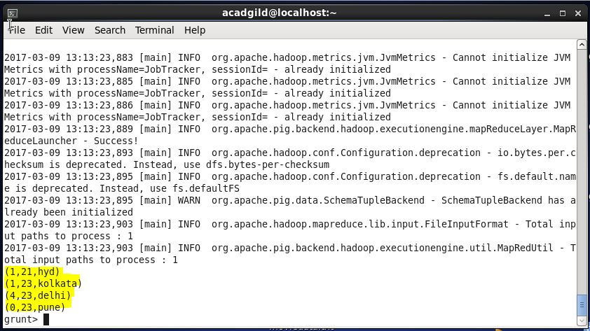

1. Filter

The FILTER operator is used to select the required tuples from a relation based on a condition.

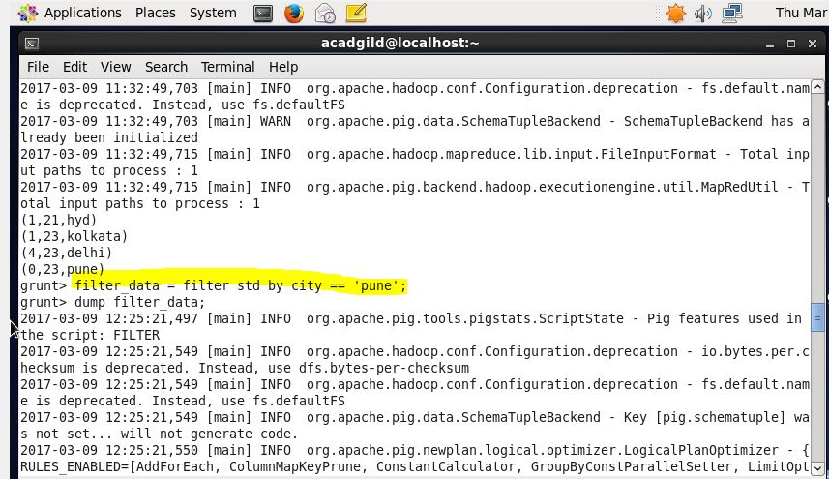

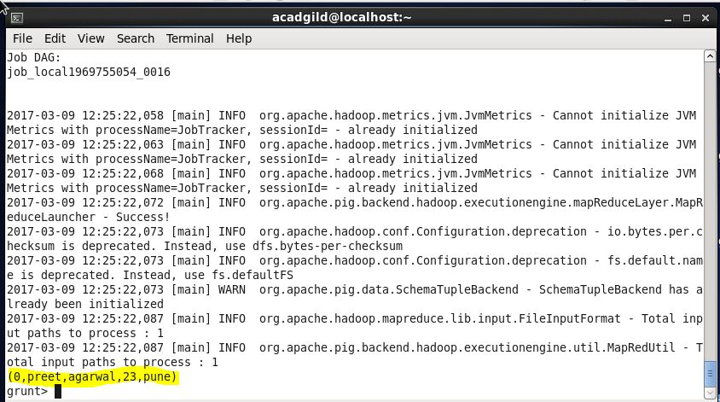

1. Group By

The GROUP operator is used to group the data in one or more relations. It collects the data having the same key.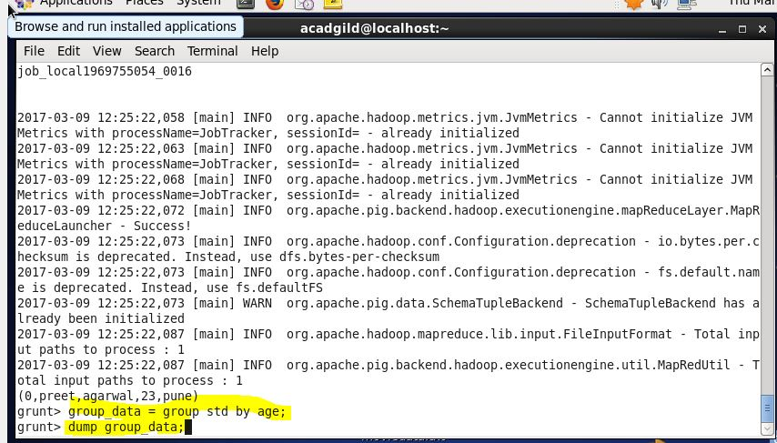

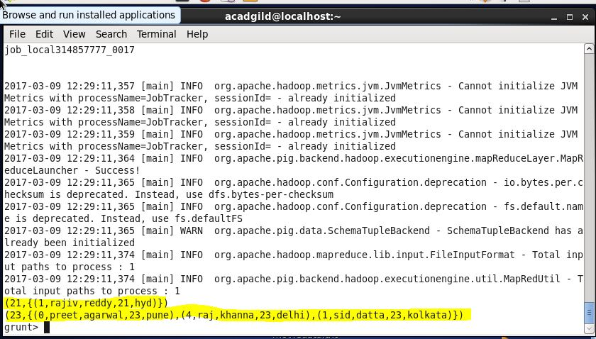

1. Order By

The ORDER BY operator is used to display the contents of a relation in a sorted order based on one or more fields.

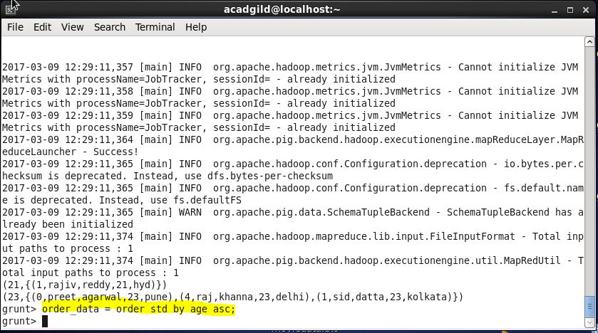

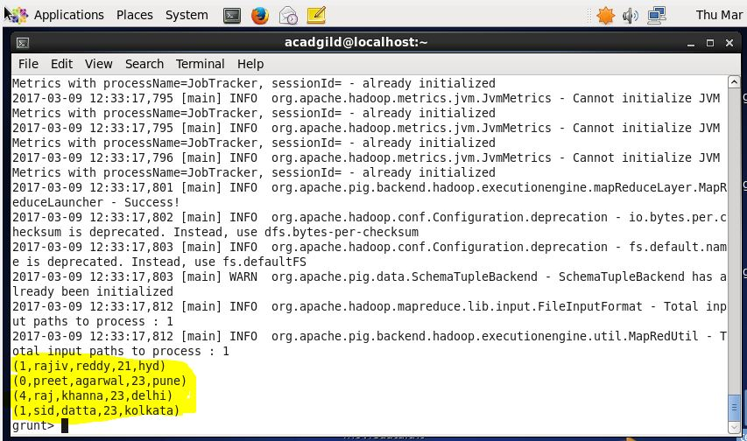

1. Describe

The describe operator is used to view the schema of a relation.

